**Timberline Fire Protection District   
Regular Meeting**July 15, 2025, at 6:00PM

Station #3, 19126 Highway 119, Black Hawk CO 80422

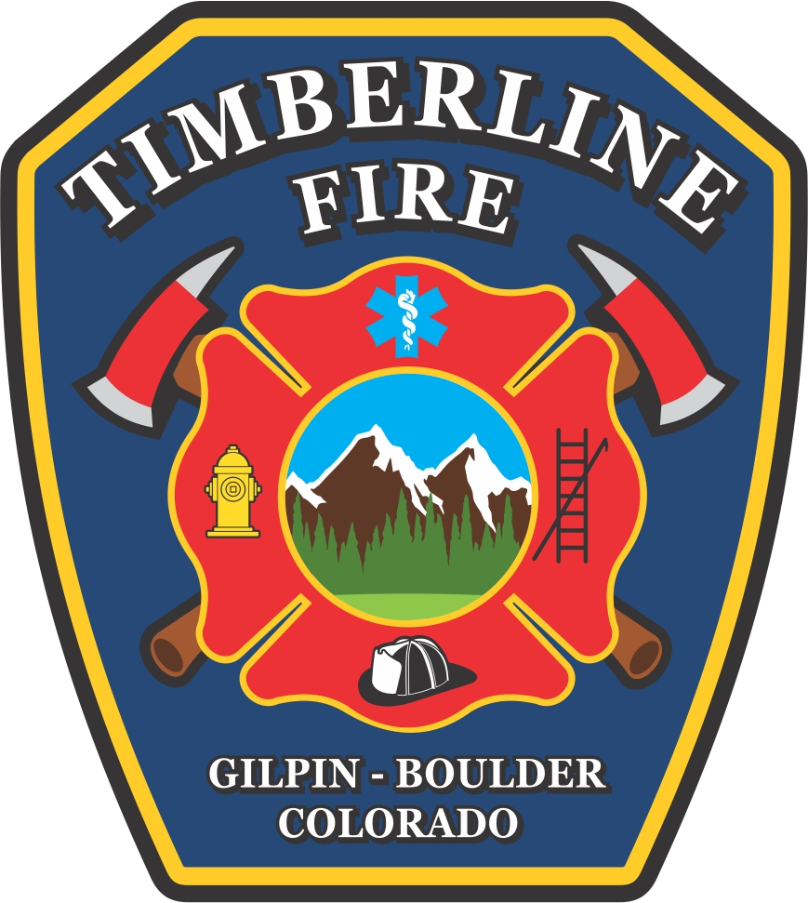

**Call to Order/Pledge of Allegiance/ Moment of Silence/Roll Call**

**Changes to Agenda/Conflicts of Interest**

**Correspondence:**

* Letter to the Editor: Jack Hidahl thanking the Mitigation Team
* Thank you from the Timberline Volunteer Firefighter Foundation

**Hearing:** 2024 Amended Budget

**New Business:** Adopt 2024 Amended Budget

**Presentation:** Adams Group, LLC: 2024 Audit Report (via Zoom)

**Approve minutes**:   
Regular Meeting: June 10, 2025

**Public Comment** (limited to 5 minutes per speaker)

**Treasurer’s Report**:   
June 2025: Unaudited Financials

**New Business:**IGA with Nederland Fire Regarding Mitigation Program

**Continued Business:**

Capital Projects:

* Station 3: Bay Addition
* Schedule Special Board Meeting for Contract Amendment

**Chiefs Report:**

Informational/Monthly Report

**Executive Session**, if needed:

**Public Comment** (limited to 5 minutes per speaker)

**Adjourn**

**Announcements:**

Next Meeting:

* Regular Meeting: August 19, 2025, at 6:00PM (meeting was moved from August 12, 2025)  
  Station 3, 19126 Highway 119, Black Hawk CO 80422